Task 10 Outputs

LS2_hog_5_cpd, label = 0, k=10

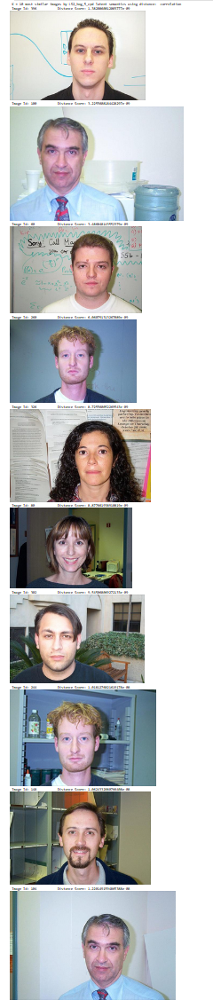

LS2_hog_5_cpd, label = 20, k=10

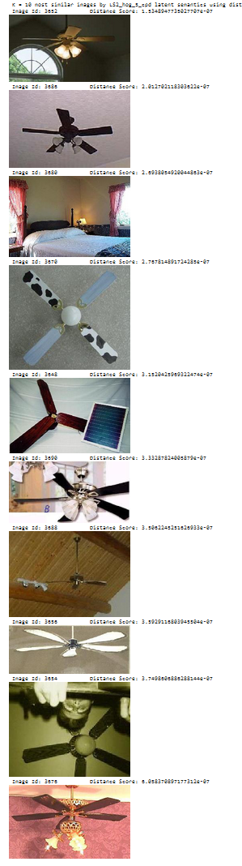

LS2_hog_5_cpd, label = 100, k=10

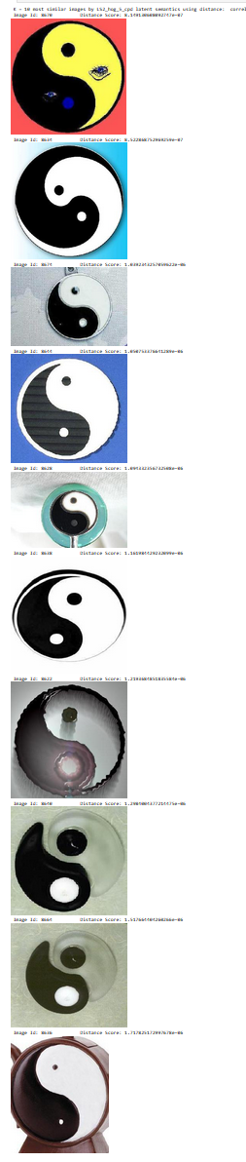

LS4_resnet_5_svd, label = 0, k=10

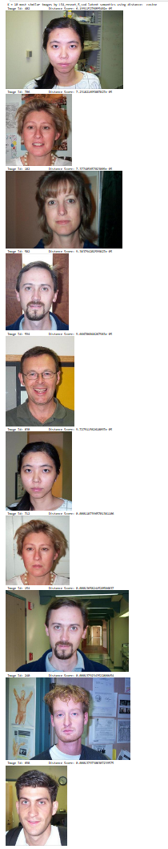

LS4_resnet_5_svd, label = 20, k=10

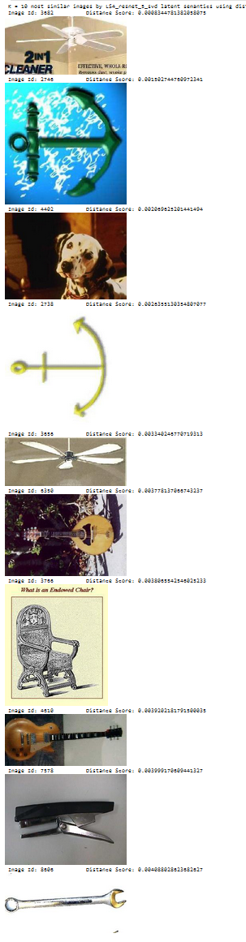

LS4_resnet_5_svd, label = 100, k=10

